(Group 5): Amanda Aveldanez, Olivia Curtis, Avery Davis, Ananya Suresh
Dr. McKay
EPID 4070
4/8/2026
Epidemiology Replication Study Final Project
Introduction:
Obesity is a chronic, relapsing condition, with a 40% prevalence in the United States adult population (World Health Organization, 2025). It is influenced by a combination of environmental, psycho-social, and genetic factors. Environmental determinants, such as access to affordable healthy food, spaces for exercise, and an effective health system identification of excess weight gain at an early stage are critical in its development (World Health Organization, 2025).
In addition to these factors, sleep has emerged as an important component of overall health and emotional wellbeing. Adequate sleep is associated with improved stress levels, heart health, and lower risk of chronic diseases including obesity (CDC, 2024). However, approximately one-third of Americans report not getting sufficient sleep, with growing evidence suggesting that lack of sleep increases obesity prevalence (National Institute of Health, 2022). Previous research has primarily examined sleep duration and sleep quality as separate factors, despite evidence suggesting that both contribute to obesity risk (Beccuti, Pannain, 2013). This approach may overlook the combined and cumulative effects of multiple sleep behaviors.
The study titled “Association between sleep duration and patterns and obesity: a cross-sectional study of the 2007–2018 National Health and Nutrition Examination Survey” aimed to address this gap by developing a sleep pattern score, capturing the combined effects of sleep duration and sleep quality to evaluate its relationship with obesity and provide a more comprehensive understanding of how sleep influences obesity. In our replication paper, we will reproduce Table 1, and part of Table 3 and Figure 3 from the original article and compare our findings with those reported in the literature.
Methodology:
The original study used a cross sectional design based on the data from the National Health and Nutrition Examination Survey (NHANES) over the 2007-2008, 2015-2016, and 2017-2018 cycles in order to evaluate the association between sleep duration and obesity in the US among a specific set of adults. The data from the NHANES uses a multistage probability sampling design to make sure that data is nationally representative of the population (civilian and noninstitutionalized). The participants of this study completed survey questionnaires, physical exams and lab assessments conducted by health care professionals in order to accurately assess overall health and sleep patterns.
The duration of sleep patterns was assessed using self reported data from surveys and sleep questionnaires. These surveys reported the average number of hours participants slept per night on weekdays or work days. Based on these reports, sleep patterns were categorized into three different categories including; short sleep (less than 7 hours), normal sleep (7-9 hours), and long sleep (over 9 hours). Then obesity was defined using the BMI scale, calculated from measures height and weight obtained during the physical examination portion of the study. Generally, a BMI over or equal to 30.0 kg/m^2 was considered obese.
The study included several uncontrolled/confounding factors such as age, sex, and race/ethnicity. Lifestyle related variables including smoking status, average alcohol consumption, and physical activity levels were also taken into account. The study also considered health related variables like hypertension and diabetes along with dietary intake variables taken from a first day dietary recall interview. These variables were selected based on their established associations with both sleep and obesity outcomes.
Descriptive statistics were first calculated to summarize participant characteristics across sleep duration categories. Mean, standard deviation, and percentages were among the main statistical data points used. Differences between groups were compared using the appropriate statistical test, using p values to determine statistical significance. Primary analysis was calculated using logical regression models to examine the associations between sleep patterns and obesity. The study was able to report multiple models with progressive adjustments for covariates, allowing for evaluation of how different factors influenced the relationship.
Specifically, the unadjusted model assessed the relationship between sleep duration and obesity. Subsequent models incrementally adjusted for demographic variables, lifestyle behaviors, and other impacting health conditions. This was followed by a full adjustment to the data which included physical activity levels as well as dietary intake. This stepwise modelling approach allowed the researchers to isolate the independent effect of sleep duration on obesity while accounting for potential confounders.
In our study replication, for all the methods and figures, data were obtained from the National Health and Nutrition Examination Study (NHANES) demographics data from the 2007-2008, 2015-2016, and 2017-2018 cycles from their website. All analyses were conducted using R. We started with 29,374 participants (the same as the article). The data on the sleep questionnaire and the BMI questionnaire were not included in the published study data. We merged the three datasets containing 2007-2008, 2015-2016, and 2017-2018 SLQ (sleep questionnaire) data and merged the three datasets with body measurements data. The Datasets for “Dietary Interview - Total Nutrient Intakes, First Day”(DR1TOT) for the covariates in the data were also added for the years 2007-2008, 2015-2016, and 2017-2018. The datasets for SMQ (smoking), ALQ (alcohol), PAQ (physical activity), DIQ (diabetes), BPQ (hypertension) for the years 2007-2008, 2015-2016, 2017-2018 were downloaded and merged. The total observations started with 29,374 participants, which is the same as the official study chart. As in the study, the participants younger than 20 were excluded from the data using the variable DMDHRAGE (n= 12,151), which was the same as the official study, as well as individuals who were pregnant (n= 182), consistent with the official study. A total of 1035 participants had missing body mass index data,while excluding those who are under 20 from the count (compared to 1,034 in the original study). Those with missing pregnancy status were retained, as they likely represented male participants.
For the replication of Table 1, participants without both questionnaire and examination data (RIDSTATR) were excluded. Participants missing sleep data were removed after restricting the sample to eligible adults with complete BMI and examination data. Due to limited methodological detail in the original study, exclusion of missing sleep data was approximated based on available variables. A total of 10,457 participants were excluded due to missing sleep data, consistent with the original study. Those with missing covariate data were also removed resulting in 976 compared to 1,010 in the official dataset. This resulted in a final data population of 4,574 participants (original study n= 4540).
To recreate Table 3, the data sample size was 4,574 instead of the official paper’s 4,540 sample size, which explains some differences in numbers within the tables. There was no explicit BMI score that was defined in the study so a minimum value of 30.0 kg/m² BMI score was used to determine participant obesity. Sleep duration was categorized by short (less than 7 hours), normal (7-9 hours), and long (>9 hours). In Table 3, regression models were constructed to examine sleep duration and obesity. An unadjusted model was first estimated to assess the crude association between sleep duration and obesity. Four models were specified: Model 1 adjusted for demographic variables; Model 2 adjusted for smoking and alcohol use; Model 3 adjusted for hypertension and diabetes; Model 4 adjusted for physical activity and energy intake. In Model 4, physical activity was found using the PAQ650 variable, however, the exact variable used in the original study was not explicitly specified. The official study may have used a combined calculated variable such as combining moderate and vigorous physical activity or other variables that were not specified and may differ from the replication methods.
For Figure 3, the association between sleep pattern score and obesity was examined using crude and adjusted models, as well as stratification by hypertension by hypertension status (yes vs. no). Obesity was coded as 1=obese and 0=not obese based on the BMI values (over 30.0kg/m² considered obese). Sleep pattern scores were coded such that higher values indicated poorer sleep patterns. Analysis was conducted using the final analytic sample after exclusions. Odds ratios and 95% confidence intervals were estimated overall and stratified by hypertension status (yes vs. no). The p-value for hypertension (P=0.846) was calculated to assess whether the association between sleep pattern score and obesity differed by hypertension status.

Results:
Table 1:
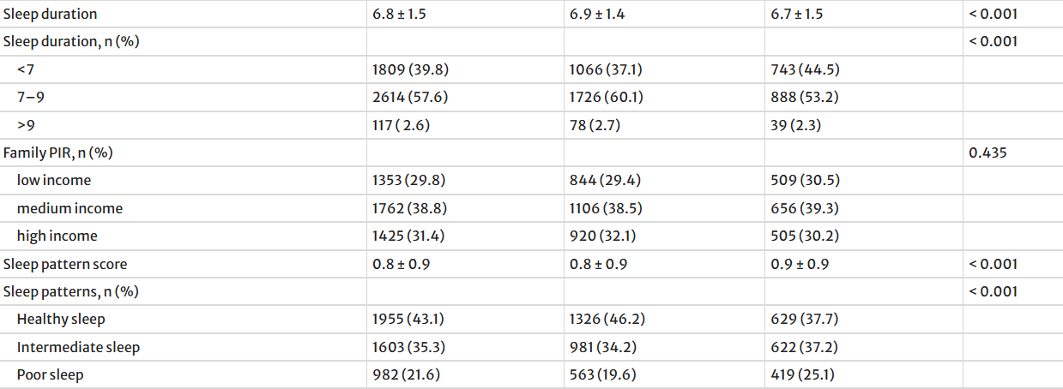
Replicated Table 1:
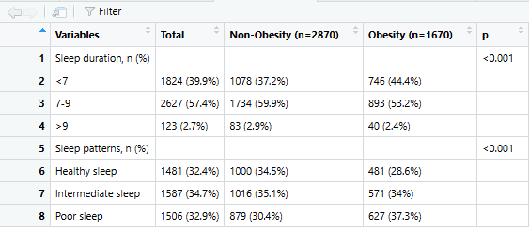
Table 1 presents the baseline characteristics of the study population, stratified by obesity status. Patterns in sleep duration and sleep quality can already be observed at this descriptive level, with obese individuals more likely to report shorter or poorer-quality sleep. When sleep duration was categorized, the majority of participants reported sleeping 7–9 hours (57.6%), followed by less than 7 hours (39.8%), while only 2.6% reported sleeping more than 9 hours. A greater proportion of the obesity group reported sleeping less than 7 hours (44.5%) compared with the non-obesity group (37.1%), whereas 7–9 hours of sleep was more common among the non-obesity group (60.1% vs. 53.2%), suggesting a relationship between shorter sleep duration and obesity (p < 0.001). Our replicated Table 1 also demonstrates a clear association among sleep duration, sleep patterns, and obesity status, consistent with the original table's findings. Individuals in the obesity group in our table were more likely to report short sleep duration (<7 hours), with 44.4% of obese participants sleeping less than 7 hours compared with 37.2% of non-obese participants. Similarly, poor sleep patterns were more prevalent in the obesity group, whereas healthy sleep patterns were more common in the non-obesity group. When comparing this table to the other table, both show the same overall pattern, even though the exact percentages differ by 0.1%. In both, individuals with obesity consistently have higher rates of short sleep and poor sleep patterns, while those without obesity are more likely to have healthier sleep behaviors.

Table 3:
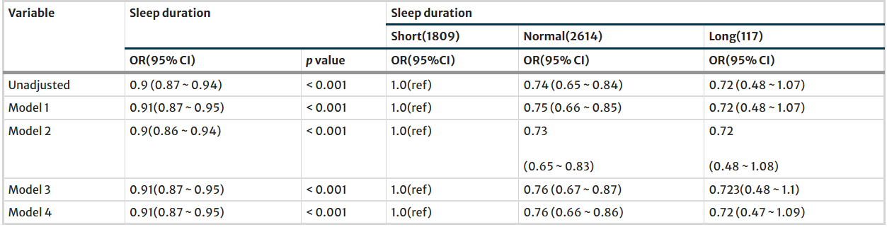
Recreated Table 3:
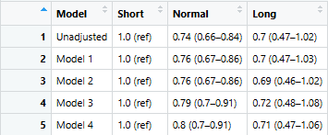
Table 3 presents the association between sleep duration and obesity across multiple models. Short sleep is used as the reference category, with a value of 1.0 across all models. The normal sleep category ranges from 0.73 (95% CI: 0.65–0.83) to 0.76 (95% CI: 0.67–0.87), with confidence intervals that remain fairly narrow across models. The long sleep category remains close to 0.72 across all models, with wider confidence intervals than normal sleep, ranging from approximately 0.47 to 1.09. Overall, the values change only slightly from the unadjusted model through Model 4. Compared with our recreated table, the numerical values are very similar. In the recreated table, normal sleep ranges from 0.74 (95% CI: 0.66–0.84) to 0.80 (95% CI: 0.70–0.91), while in the first table, it ranges from 0.73 (95% CI: 0.65–0.83) to 0.76 (95% CI: 0.67–0.87), so the first table’s estimates are slightly lower in the later models. For long sleep, both tables remain close, with the first table around 0.72 (95% CI: 0.47–1.09) and the second table ranging from 0.69 (95% CI: 0.46–1.02) to 0.72 (95% CI: 0.48–1.08). Both tables use short sleep as the reference group and show nearly identical numerical patterns across all models, indicating strong consistency between the two.
Table 1
Table 1

Figure 3:
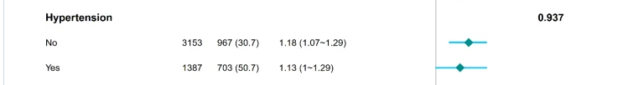
Recreated Figure 3:
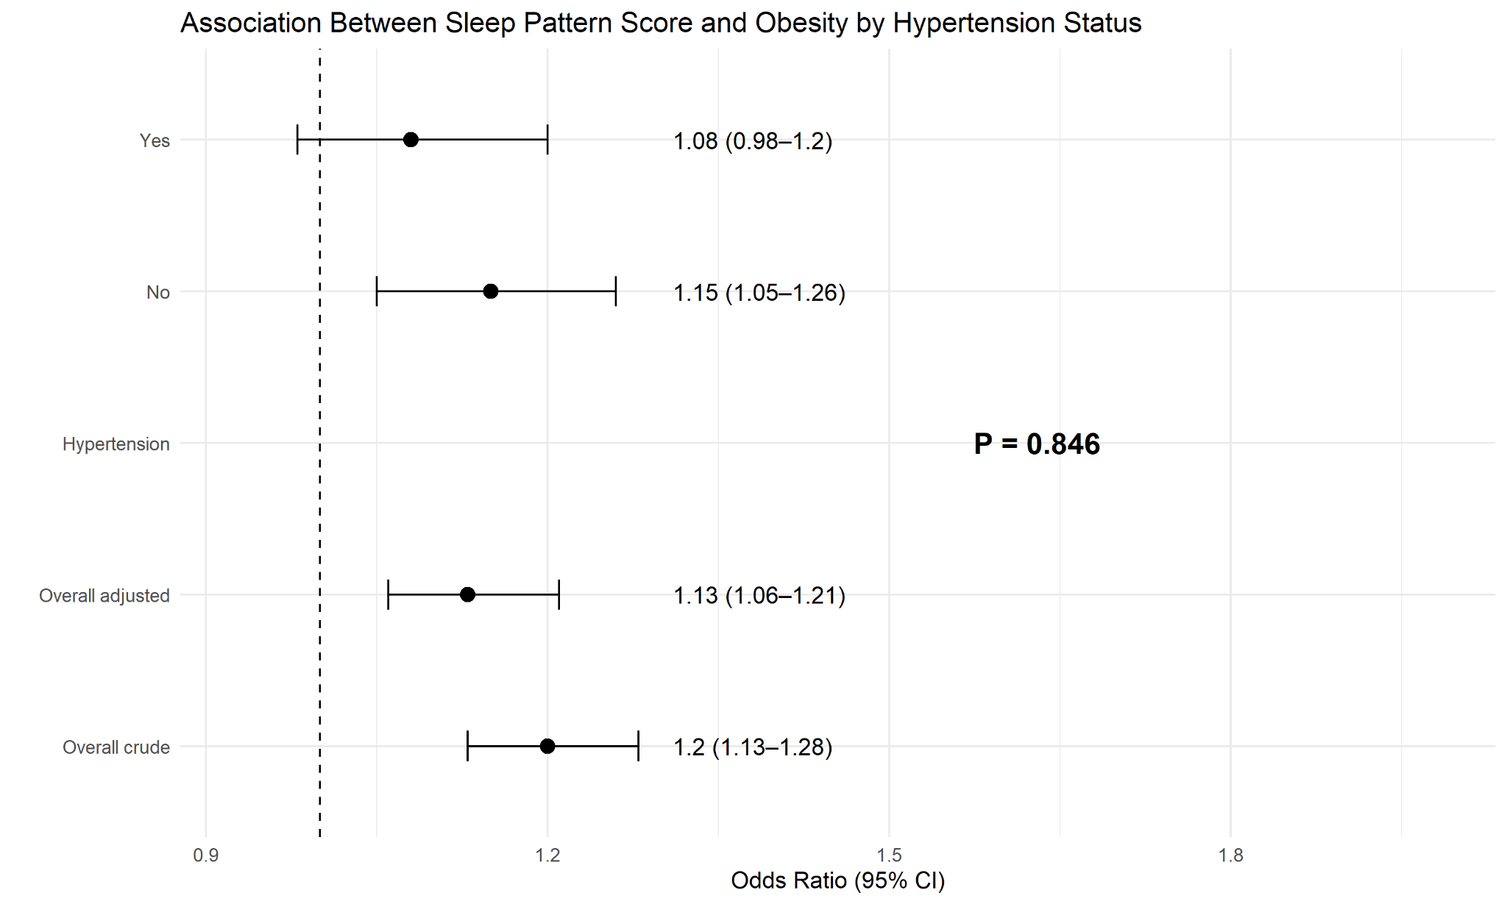

Figure 3 presents the association between sleep pattern score and obesity stratified by hypertension status. Among individuals without hypertension, the odds ratio is 1.18 (95% CI: 1.07–1.29), based on a sample of 3153 participants with 967 cases (30.7%). Among those with hypertension, the odds ratio is slightly lower at 1.13 (95% CI: 1.00–1.29), with 1387 participants and 703 cases (50.7%). The interaction p-value is 0.937, indicating very similar estimates between the two groups. Our replicated Figure 3 also presents odds ratios for the association between sleep pattern score and obesity by hypertension status. In the replicated graph, the overall crude odds ratio is 1.20 (95% CI: 1.13–1.28), which decreases slightly to 1.13 (95% CI: 1.06–1.21) in the overall adjusted model. When stratified by hypertension status, the No hypertension group has an odds ratio of 1.15 (95% CI: 1.05–1.26), while the Yes hypertension group has an odds ratio of 1.08 (95% CI: 0.98–1.20). The interaction p-value shown is 0.846, indicating very little difference between the two subgroup estimates. Compared to the other figure, the numbers are very similar overall. In the original figure, the No hypertension group is 1.18 (95% CI: 1.07–1.29) and the Yes group is 1.13 (95% CI: 1.00–1.29), while in the replicated figure, these values are slightly lower at 1.15 (95% CI: 1.05–1.26) and 1.08 (95% CI: 0.98–1.20), respectively. The p-values are also close, with 0.937 in the original figure and 0.846 in the replicated figure. Overall, both figures show nearly the same numerical pattern, with only small differences in the odds ratios and confidence intervals

Conclusion:
Obesity remains a chronic and multifactorial disease with significant prevalence in American society usually influenced by a combination of environmental, psychological, and biological factors. As showcased throughout this study, sleep has emerged as an important and easily modifiable risk factor for obesity. By examining both sleep patterns and duration, this study was able to build on existing research to better understand how sleep overall influences obesity.
With the replication of key data in the original study, specifically Tables 1 and 3, as well as Figure 3, our analysis reinforces that the role of sleep is a meaningful factor associated with obesity and possibly also other similar health outcomes. The findings support the broader understanding that inadequate or even poor quality of sleep can contribute to disruptions in metabolism along with an increased risk of chronic conditions such as hypertension and diabetes which are linked, but not mutually exclusive to, obesity risk. These results emphasize the importance of considering sleep not only as an isolated variable but in a broader behavioral and environmental context that can essentially shape long term health outcomes.
From a public health standpoint, these findings are especially important because sleep is a modifiable behavior. Lifestyle changes can put individuals at risk in a much better place that does not require an invasive intervention. Unlike genetic and structural health determinants, sleep habits are easily improved through education and lifestyle changes. The high prevalence of obesity and insufficient sleep can be fixable with dramatic positive impacts.
The paper was not entirely reproducible, as the official paper’s methodology did not specify specific variables at times and used variables that were likely calculated from existing variables from the NHANES data. For example, in Model 4 of the table it was unknown what variable was specifically used for the calculation. We used the variable PAQ650 (vigorous physical activities) which included exercise, sport, and recreational activities for calculating Model 4. However, the paper does not specify what specific variable for "physical activity” was used for the Model 4 data as no one variable in the PAQ (physical activity) data set was named “physical activity” according to the codebook . The paper may have used a weighted calculation involving more than one variable to calculate the physical activity used in Model 4 of Table 3. The methodology of the paper also did not specifically specify parameters such as BMI thresholds for obesity making complete recreation difficult.
Using the data that is publicly available and published through NHANES from 2007-2018, our group was able to reproduce the analysis described in the original datasets closely but did not recreate exact replicated results. We used R statistical software to merge and analyze the datasets to recreate Table 1, 3 and Figure 3. The replication of the study connects sleep as a contributing factor to obesity and the importance of reproducibility in scientific studies. Transparent methods and data processing is essential to ensure that research is viable and can be used in public health contexts.

Works Cited
Primary Sources:
Xu, Q., Lin, Z., Chen, Y. et al. Association between sleep duration and patterns and obesity: a cross-sectional study of the 2007–2018 national health and nutrition examination survey. BMC Public Health 25, 1460 (2025). https://doi.org/10.1186/s12889-025-22433-9
Data Codebook Sources:
Centers for Disease Control and Prevention. (n.d.-b). BMX_E. Centers for Disease Control and Prevention. https://wwwn.cdc.gov/Nchs/Data/Nhanes/Public/2007/DataFiles/BMX_E.htm#BMXBMI
Centers for Disease Control and Prevention. (2009a, September). DEMO_E. Centers for Disease Control and Prevention. https://wwwn.cdc.gov/Nchs/Data/Nhanes/Public/2007/DataFiles/DEMO_E.htm
Centers for Disease Control and Prevention. (2009, September). PAQ_E. Centers for Disease Control and Prevention. https://wwwn.cdc.gov/Nchs/Data/Nhanes/Public/2007/DataFiles/PAQ_E.htm
Centers for Disease Control and Prevention. (2020a, February). BPQ_J. Centers for Disease Control and Prevention. https://wwwn.cdc.gov/Nchs/Data/Nhanes/Public/2017/DataFiles/BPQ_J.htm
Centers for Disease Control and Prevention. (2020a, February). DIQ_J. Centers for Disease Control and Prevention. https://wwwn.cdc.gov/Nchs/Data/Nhanes/Public/2017/DataFiles/DIQ_J.htm
Centers for Disease Control and Prevention. (2020, February). SMQ_J. Centers for Disease Control and Prevention. https://wwwn.cdc.gov/Nchs/Data/Nhanes/Public/2017/DataFiles/SMQ_J.htm
Centers for Disease Control and Prevention. (2020b, March). ALQ_D. Centers for Disease Control and Prevention. https://wwwn.cdc.gov/Nchs/Data/Nhanes/Public/2005/DataFiles/ALQ_D.htm
Centers for Disease Control and Prevention. (2020b, June). DR1TOT_J. Centers for Disease Control and Prevention. https://wwwn.cdc.gov/Nchs/Data/Nhanes/Public/2017/DataFiles/DR1TOT_J.htm
Secondary Sources:
Beccuti, G., & Pannain, S. (2011, July). Sleep and Obesity. Current opinion in clinical nutrition and metabolic care. https://pmc.ncbi.nlm.nih.gov/articles/PMC3632337/
Centers for Disease Control and Prevention. (n.d.). About sleep. Centers for Disease Control and Prevention. https://www.cdc.gov/sleep/about/index.html
Centers for Disease Control and Prevention. (2024, September 24). Products - data briefs - number 508 - September 2024. Centers for Disease Control and Prevention. https://www.cdc.gov/nchs/products/databriefs/db508.htm
U.S. Department of Health and Human Services. (n.d.). What are sleep deprivation and deficiency? National Heart Lung and Blood Institute. https://www.nhlbi.nih.gov/health/sleep-deprivation
World Health Organization. (n.d.-d). Obesity and overweight. World Health Organization. https://www.who.int/news-room/fact-sheets/detail/obesity-and-overweight

